PHP & MySQL

**PHP** is a general-purpose scripting language geared towards web development. It was originally created by Danish-Canadian programmer Rasmus Lerdorf in 1993 and released in 1995. The PHP reference implementation is now produced by the PHP Group.

**MySQL** is an open-source relational database management system (RDBMS). Its name is a combination of "My", the name of co-founder Michael Widenius's daughter My, and "SQL", the acronym for Structured Query Language.

## Step 0 – Updating Package

Command: **sudo apt update**

## 

## Step 1 – Install LAMP (**L**inux, **A**pache, **M**ySQL, **P**HP) - Server

Command: **sudo apt install lamp-server^**

It will start installing the necessary packages

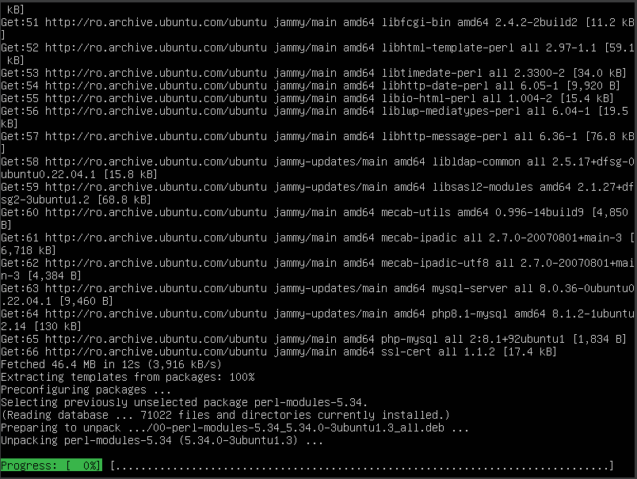After you see that it was successful check the necessary installation

* PHP (cmd: **php –v**)

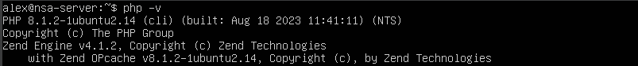

* MySQL (cmd: **sudo mysql**)

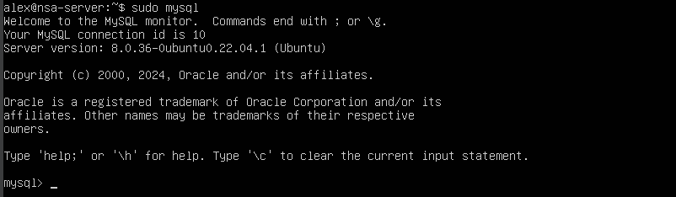

## Step 2 – MySQL functionalities

* Try to see the existing databases

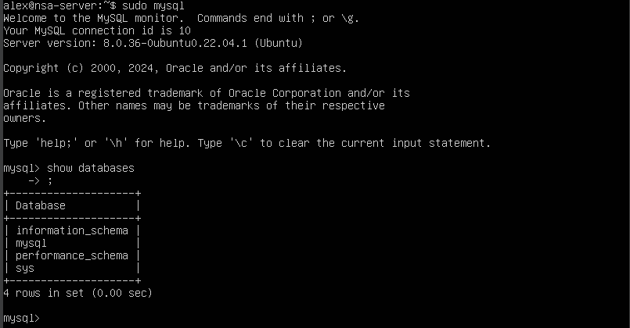

* Create a database

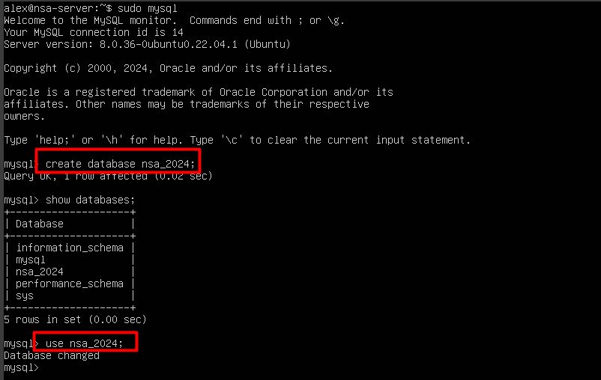

* Create a table and add an entry on it

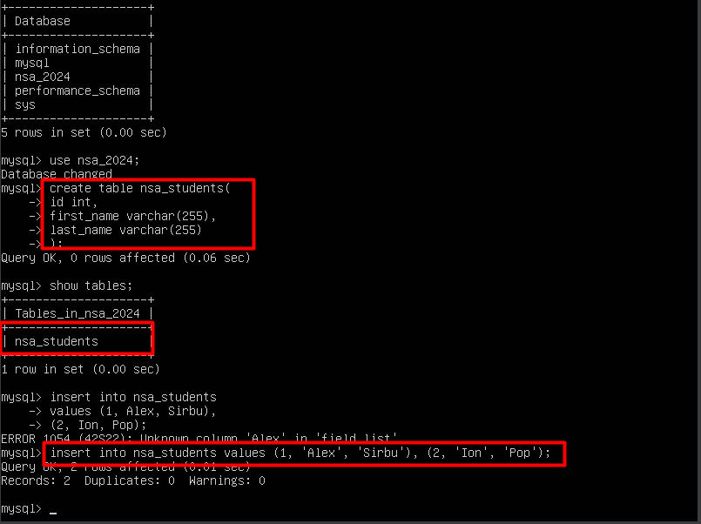

* Run a query

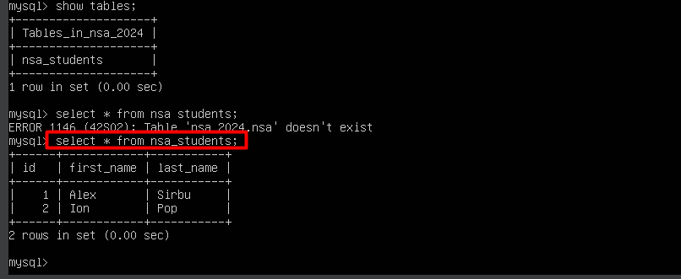

## Step 3 – Apache web server for running PHP

* Run **ifconfig** on the server (if you don’t have it, install using: **sudo apt install net-tools**)

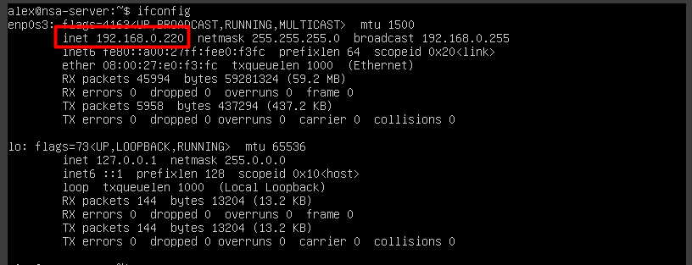

* Go in a browser and write that IP in the search bar

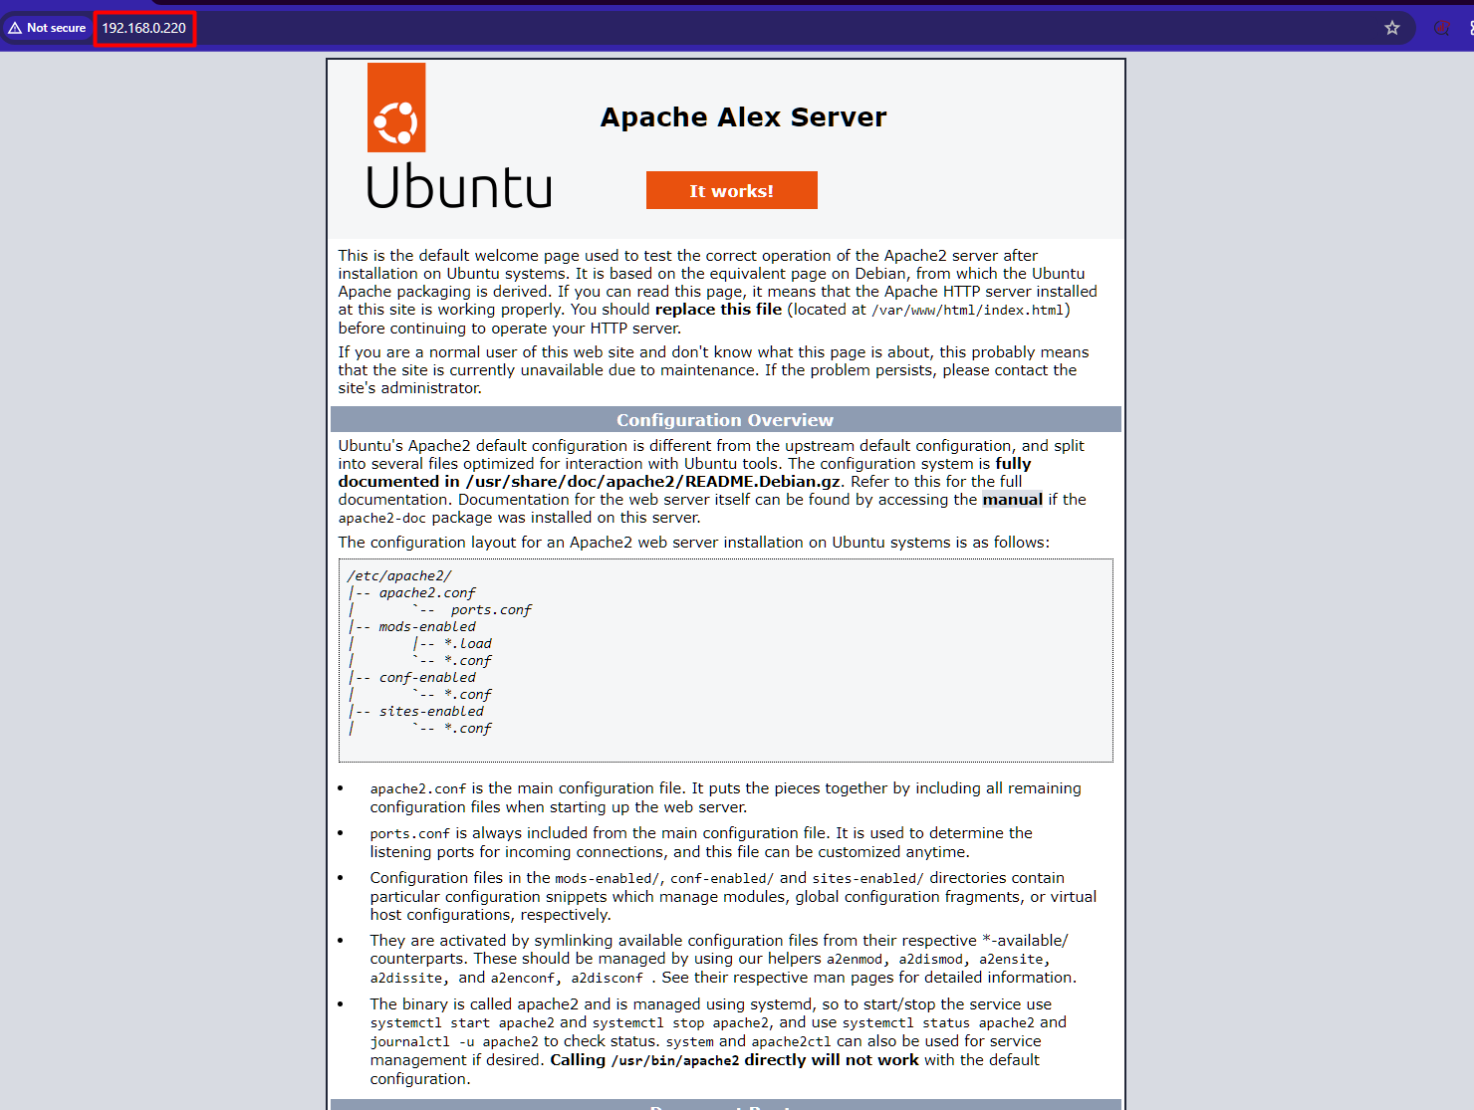

* Go to **/var/www/html** and transform the **index.html** in **index.php** 
  + Example commands
    - sudo cp index.html index.php
    - sudo rm index.html
* Open the file **index.php** using a text editor (I choose vim, can be any)
* Try writing a small PHP script, e.g., one which calculates the exact date and time

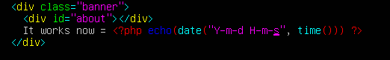

* Refresh the page in browse, every time you refresh, the exact time at the refresh will be shown

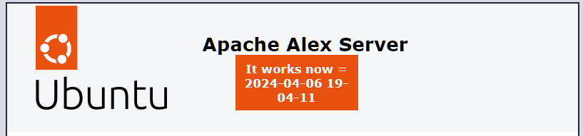

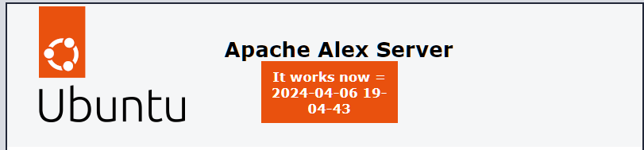

* Access MySQL from PHP (this is the PHP script)

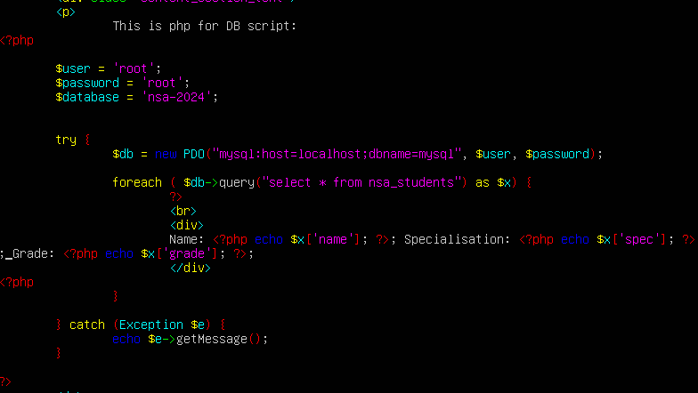

* Database and table structure

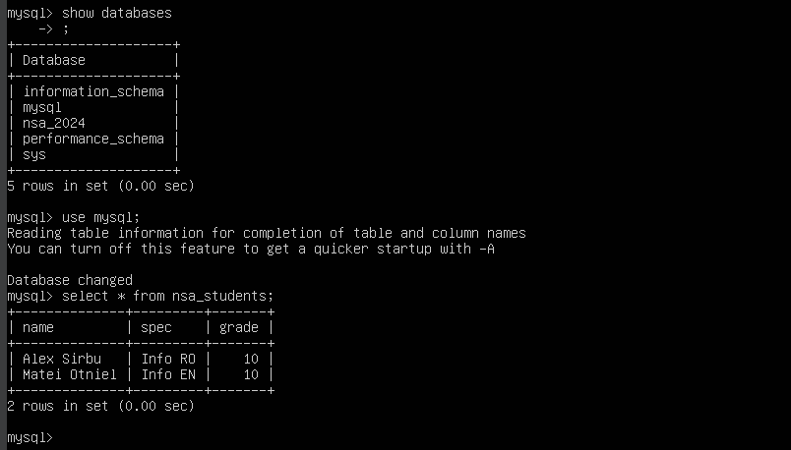

Web page:

